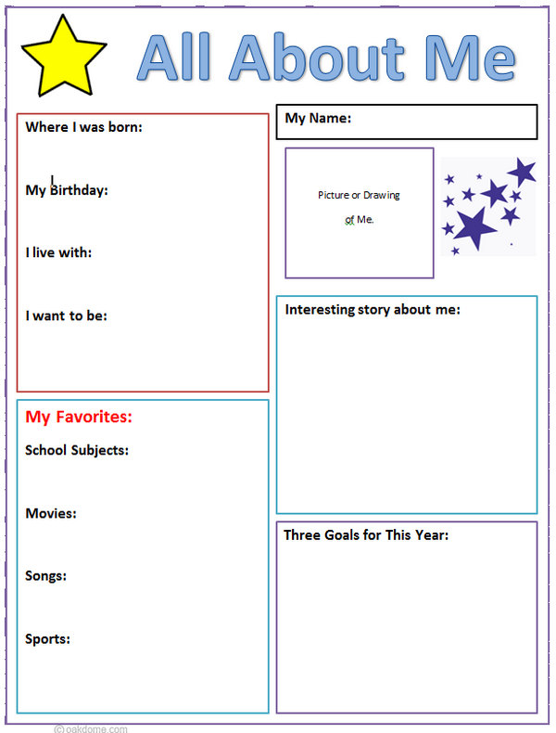

Delete Me

Delete Me

Delete Me

Delete Me

Delete Me

Delete Me

Delete Me

Delete Me

Delete Me

Delete Me

Delete Me